**EXPERIMENT:1(A)**

**AIM:** To demonstrate confusion matrix using python

**OUTPUT:**

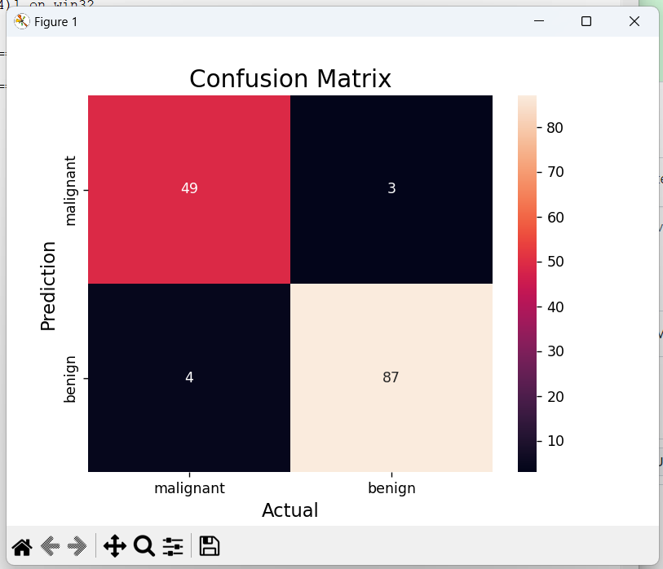

**EXPERIMENT:1(B)**

**AIM:** To demonstrate 2 class confusion matrix using python

**OUTPUT:**

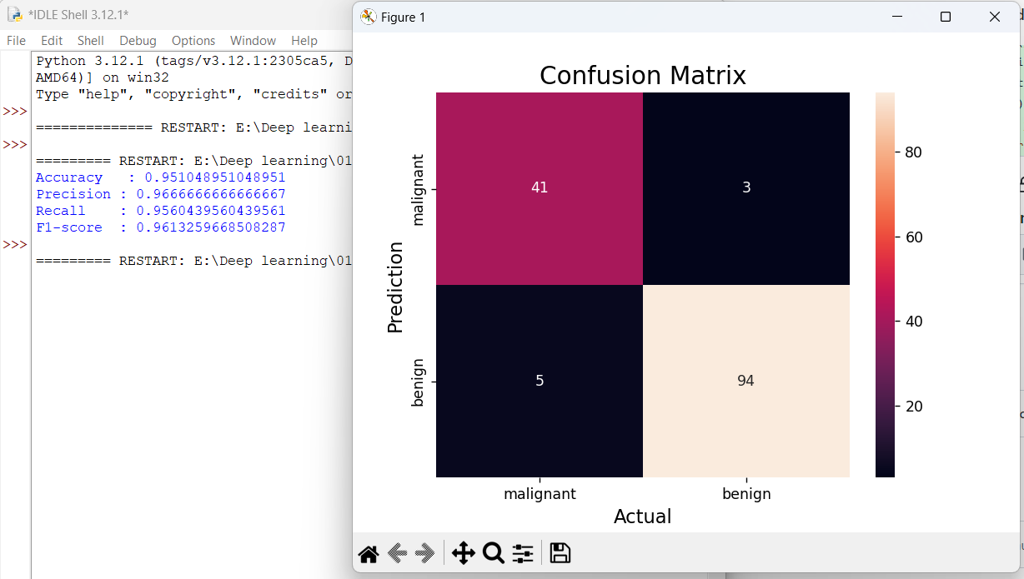

**EXPERIMENT:2**

**AIM:** Verifying the performance of a multi class confusion matrix by using choosen database with phython code

**OUTPUT:**

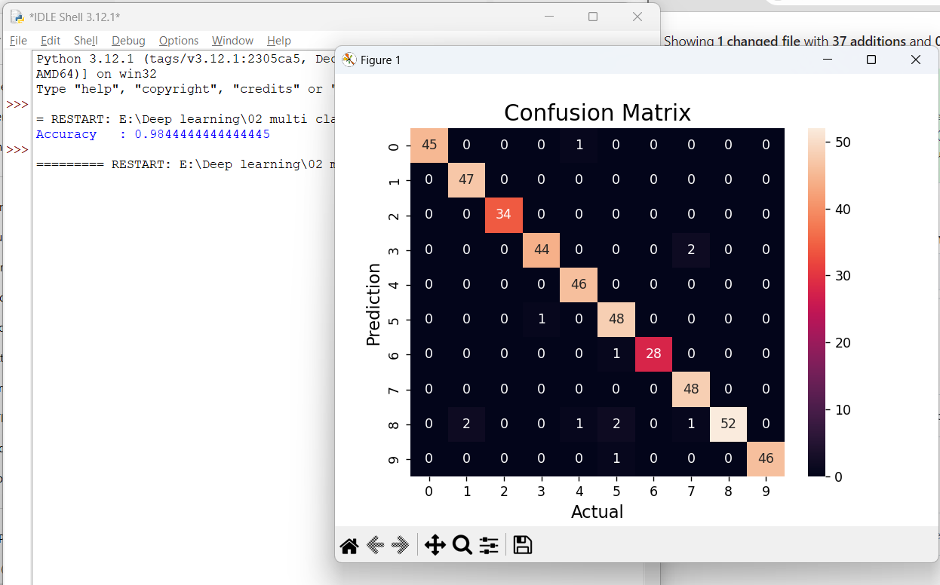

**EXPERIMENT:3**

**AIM:** : Verifying the performance of a over fitting by using choosen database with python code

**OUTPUT:**

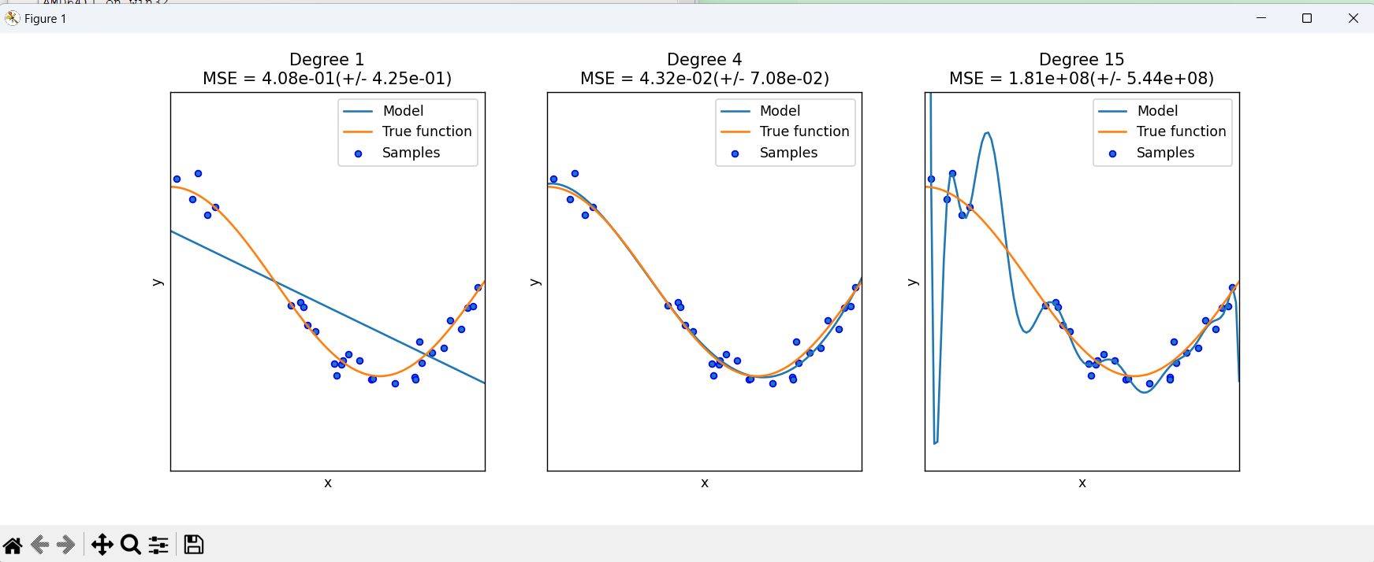

**EXPERIMENT:4**

**AIM:** To demonstrate the performance of a linear regression by using choosen database with python code

**OUTPUT:**

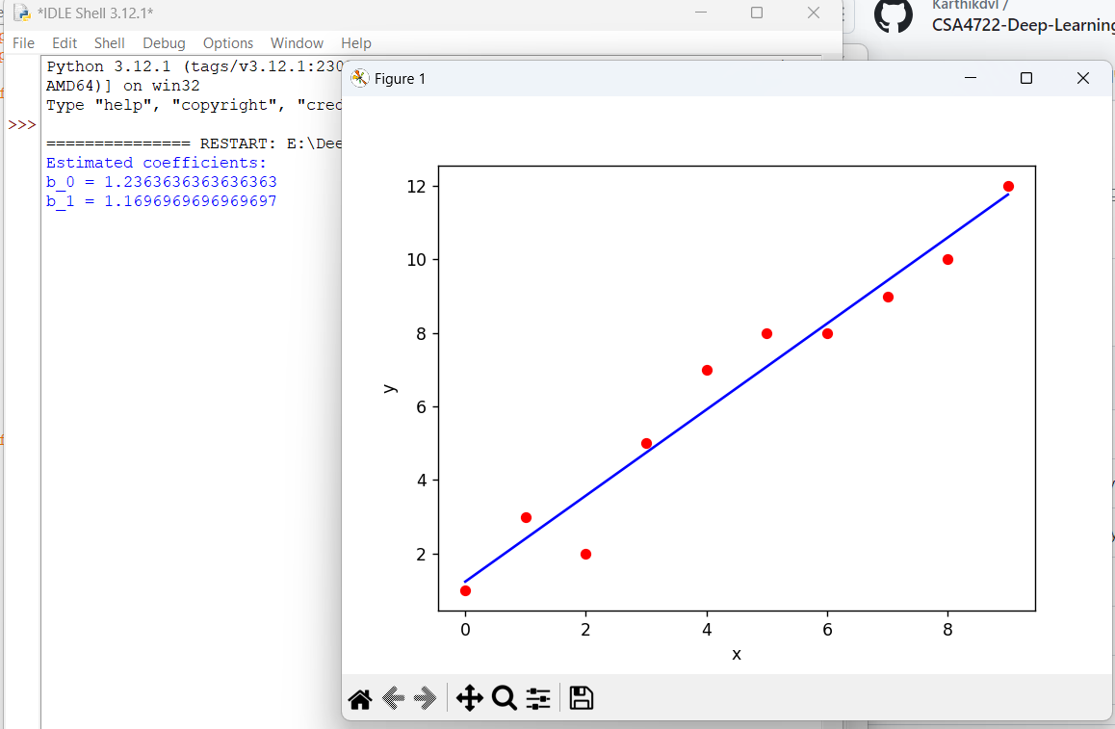

**EXPERIMENT:5**

**AIM:** : To demonstrate the performance of a logistic regression by using choosen database with python code.

**OUTPUT:**

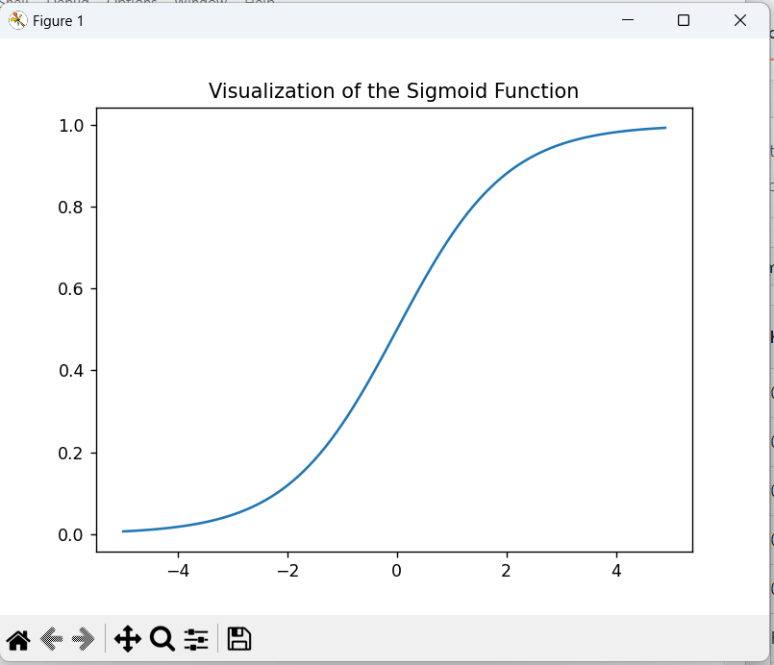

**EXPERIMENT:6(a)KNN**

**AIM:** Finding accuracy value of iris data set using KNN algorithm

**OUTPUT:**

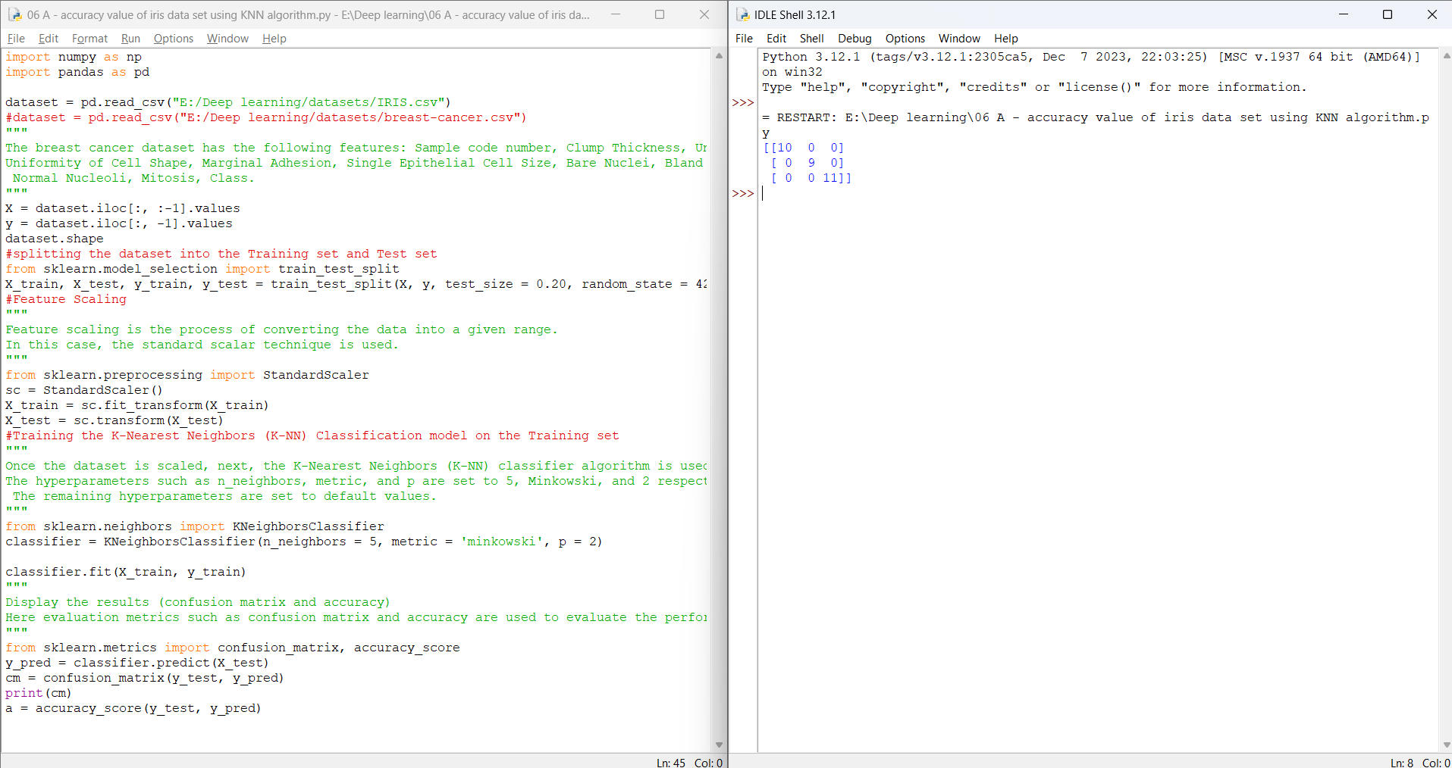

**EXPERIMENT:6(B)NAVIE**

**AIM: :** finding accuracy value of iris data set using NAVIE BAYES algorithm

**OUTPUT:**

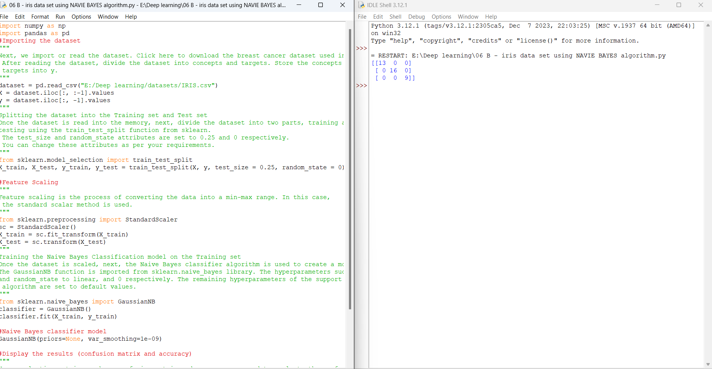

**EXPERIMENT:6(C)LOGISTIC**

**AIM: :** finding accuracy value of iris data set using LOGISTIC REGRESSION algorithm

**OUTPUT:**

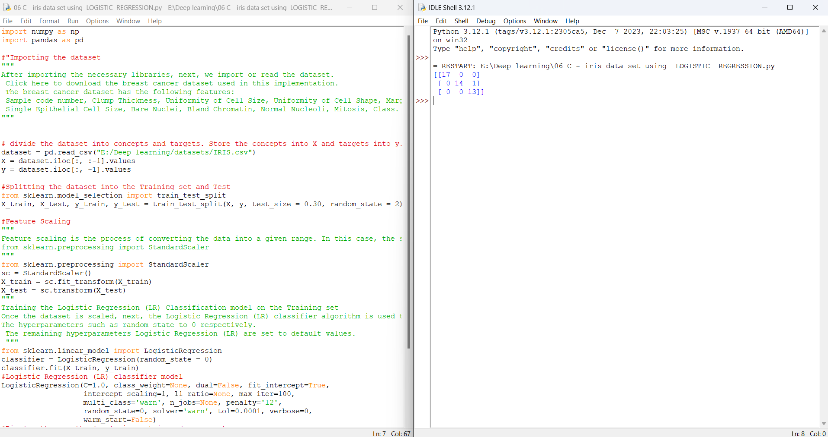

**EXPERIMENT:6(D)DECISION**

**AIM: :** finding accuracy value of iris data set using DECISION TREE algorithm

**output:**

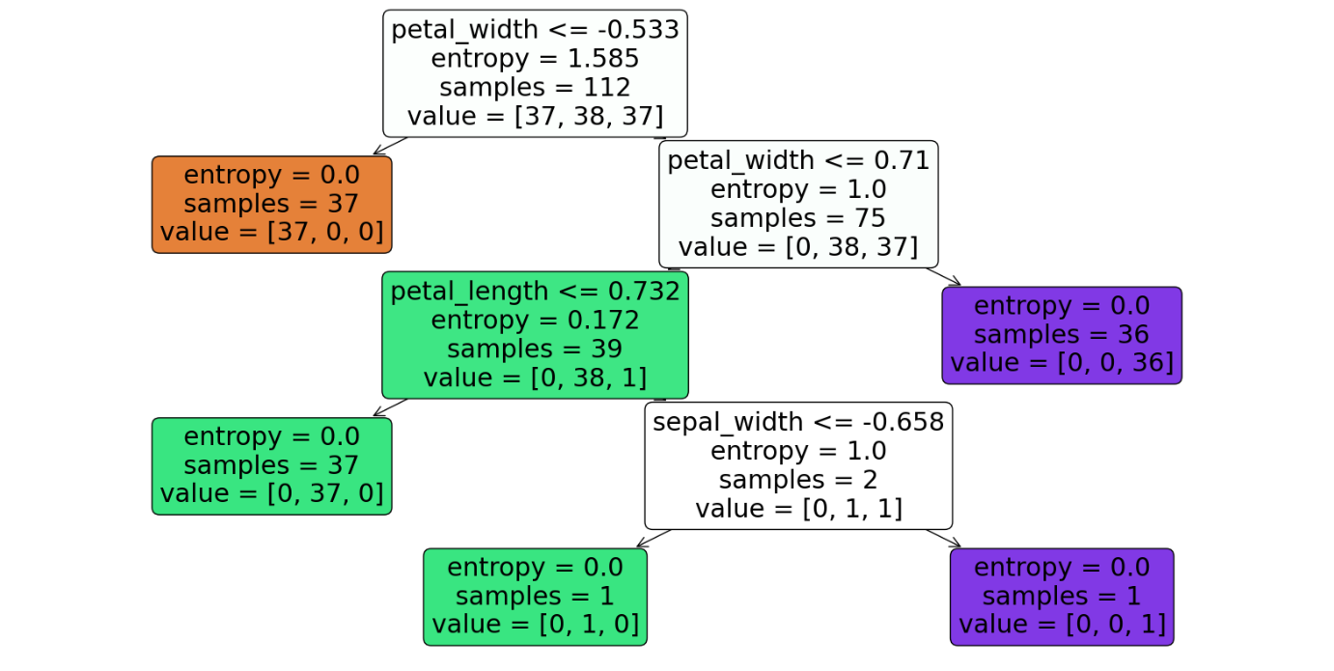

0.8947368421052632

[[13 0 0]

[ 0 11 1]

[ 0 3 10]]

**EXPERIMENT:6(E)SVM**

**AIM: :** finding accuracy value of iris data set using SVM algorithm

**OUTPUT:**

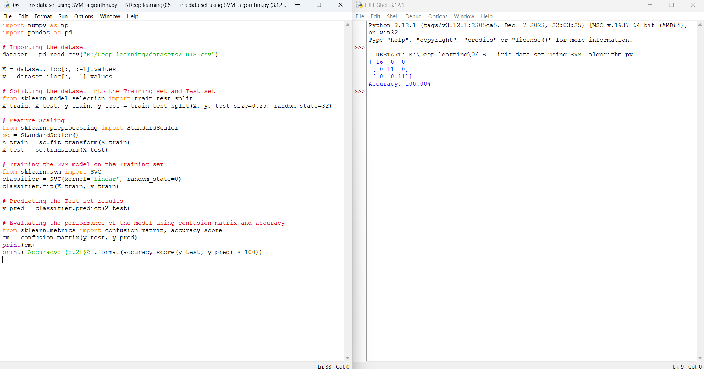

**EXPERIMENT:6(F)RANDOM**

**AIM: :** finding accuracy value of iris data set using RANDOM FOREST algorithm

**OUTPUT:**

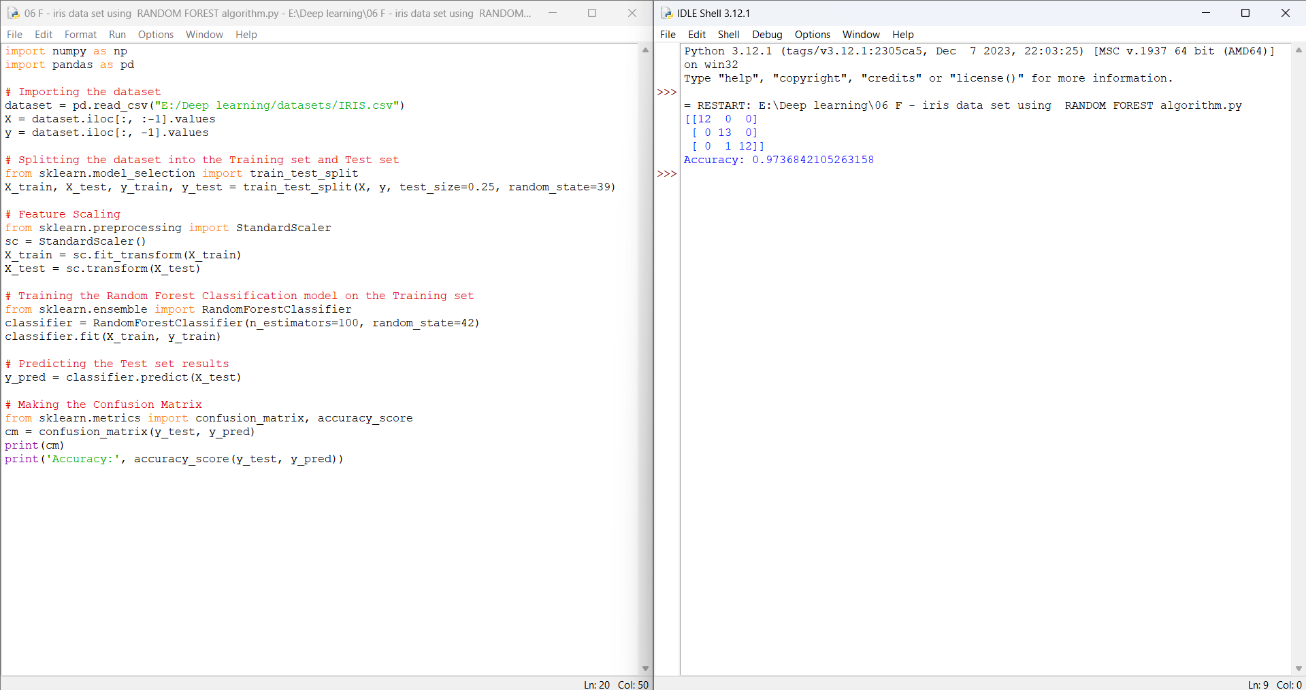

**EXPERIMENT:7(A)**

**AIM:** To demonstrate gradient descent using python(actual data)

**output:**

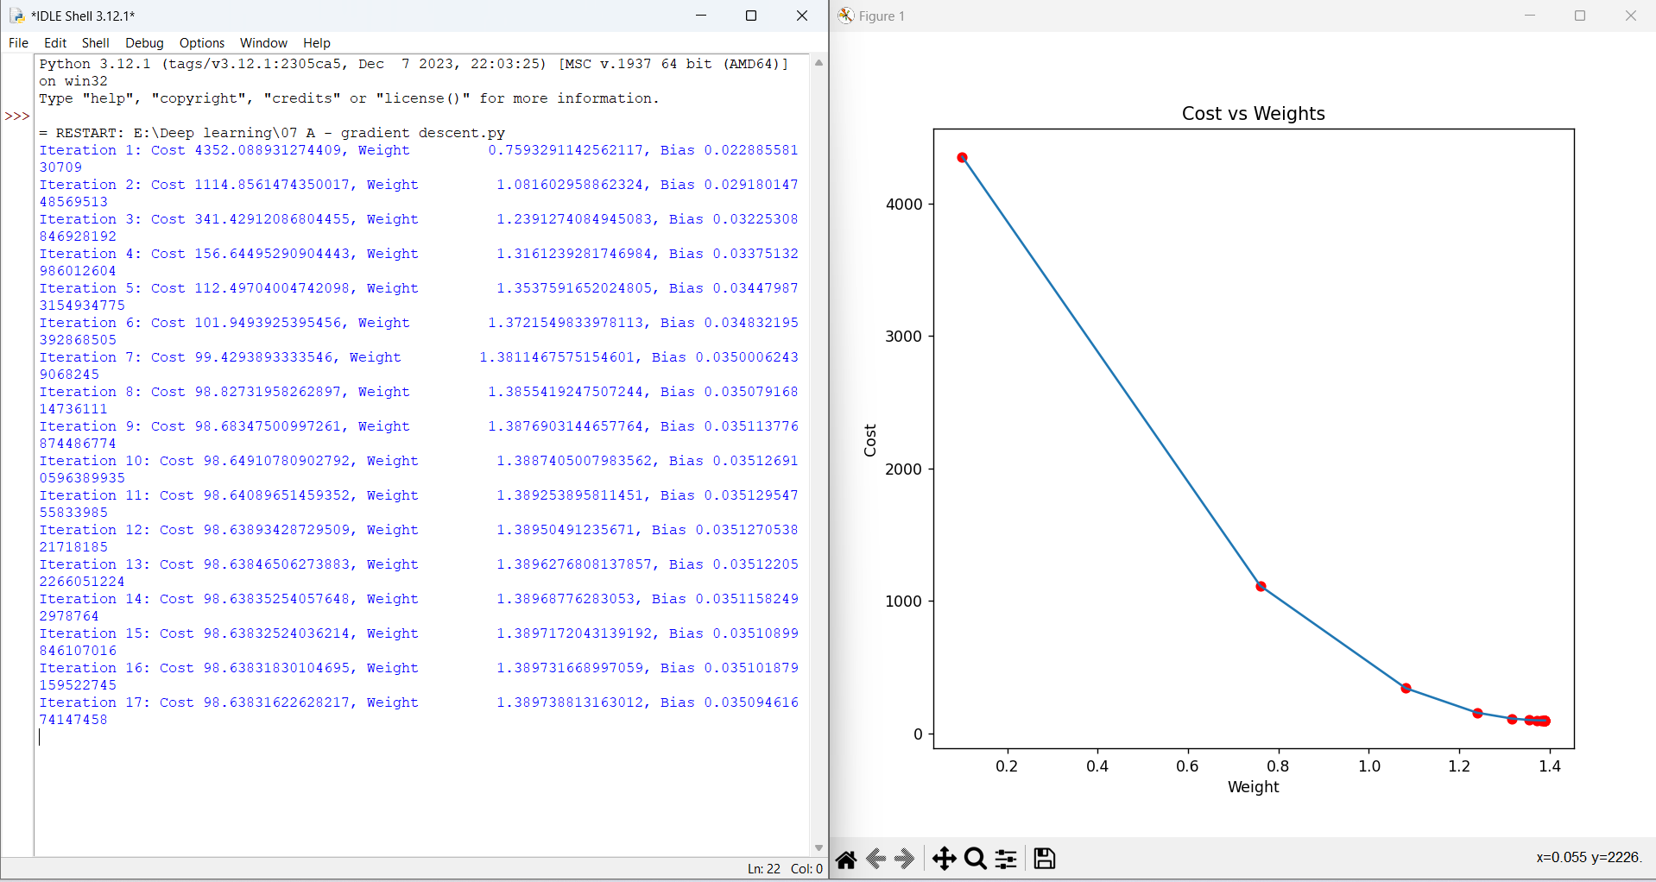

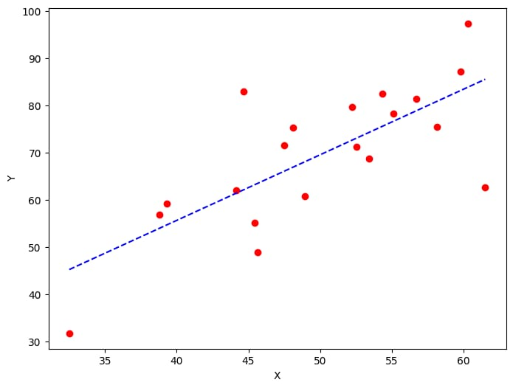

**Experiment:7(b)**

**AIM:** To demonstrate gradient descent using python( modified data)

**OUTPUT:**

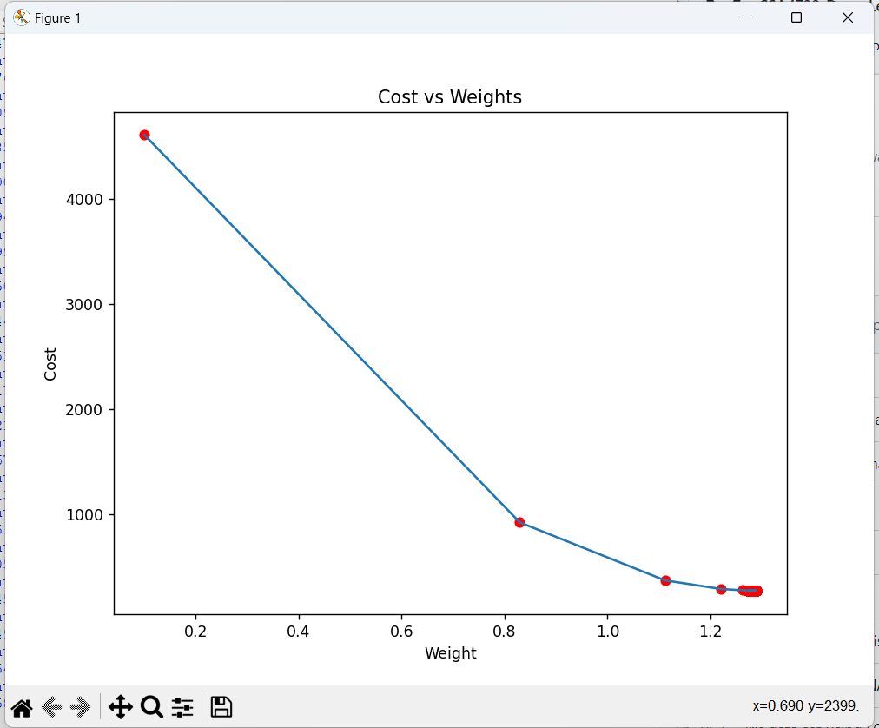

**EXPERIMENT:8(A)SEGMENTATION**

**AIM:** : Verifying the performance of a image processing by using choosen database with phython code

**OUTPUT:**

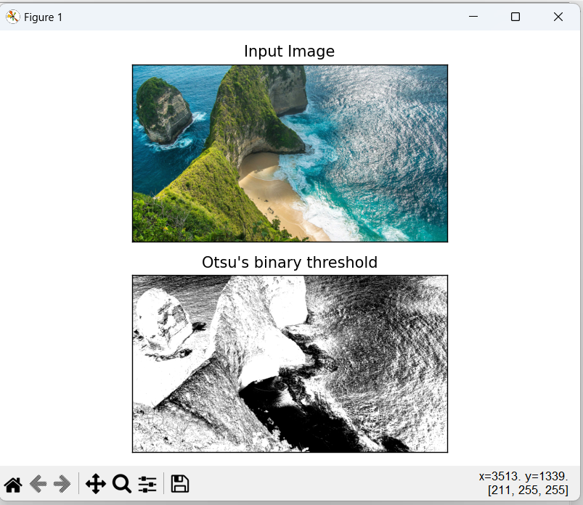

**EXPERIMENT:8(B)**

**AIM:** : Verifying the performance of a image processing by using water shed database with python code

**OUTPUT:**

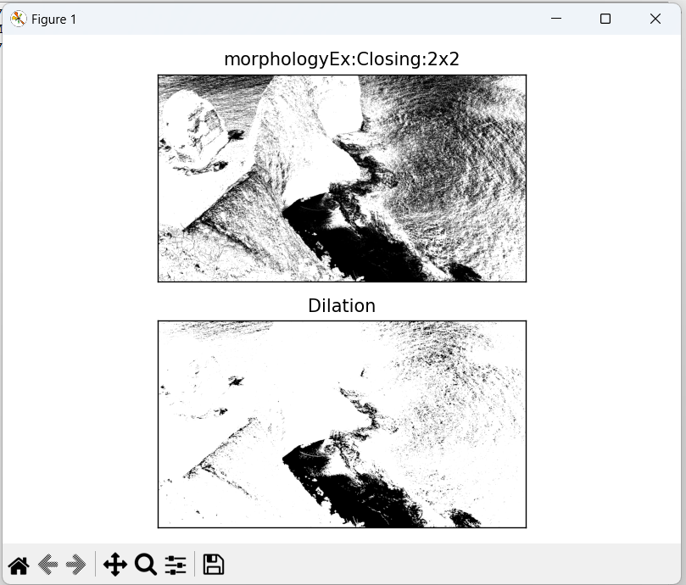

**EXPERIMENT:9 (a) TANH**

**AIM:** Neural network analysis using TANH activation

**OUTPUT:**

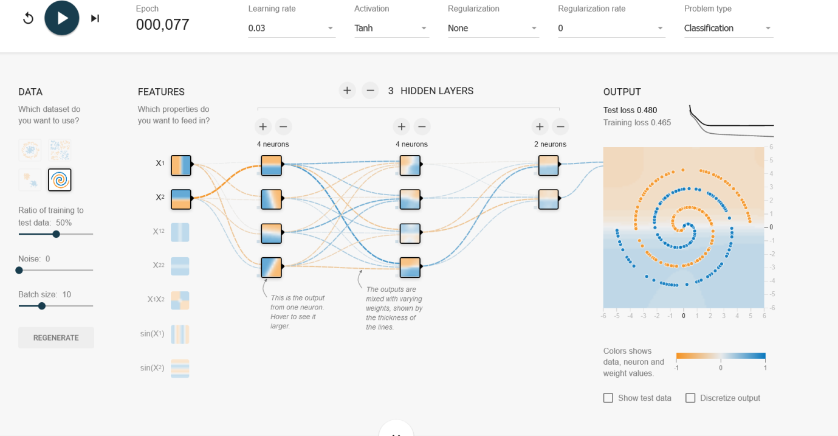

**EXPERIMENT:9(B) SIGMIOD**

**AIM:** Neural network analysis using SIGMOID activation

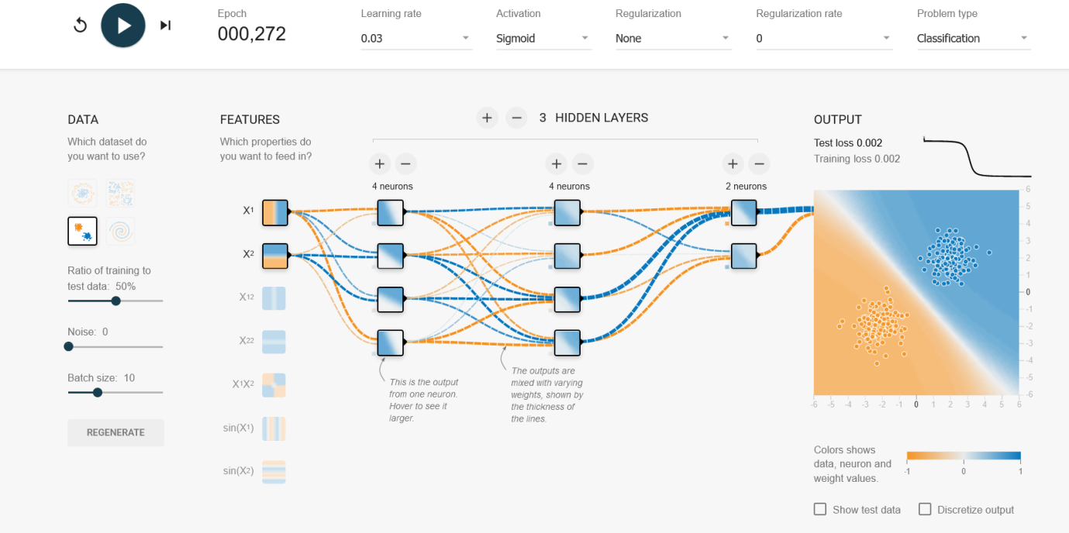

**EXPERIMENT:9(C) LINEAR**

**AIM:** Neural network analysis using LINEAR activation

**OUTPUT:** 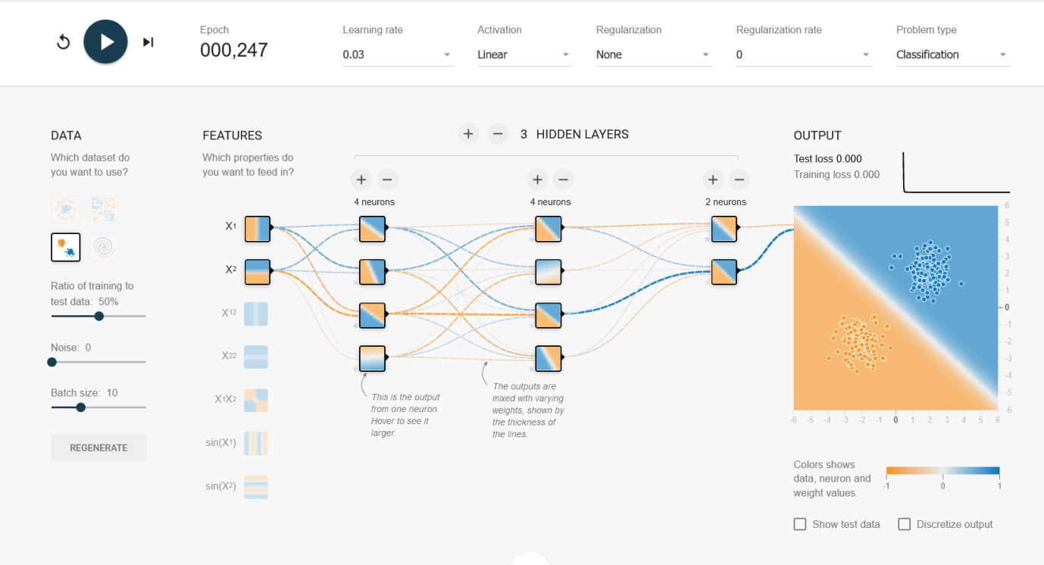

**EXPERIMENT:9(D)RELU**

**AIM:** Neural network analysis using ReLU activation

**OUTPUT:**

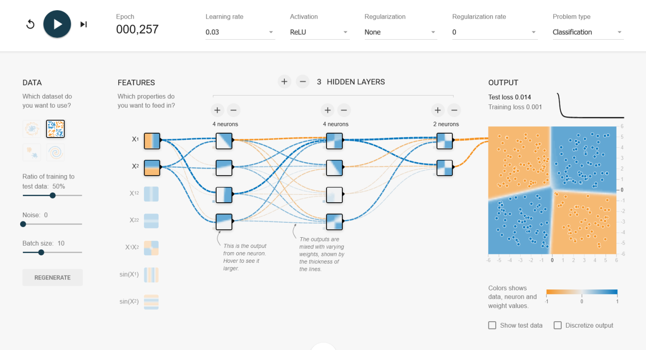

**EXPERIMENT:10**

**AIM:** To demonstrate linear separability using python code

**OUTPUT:**

